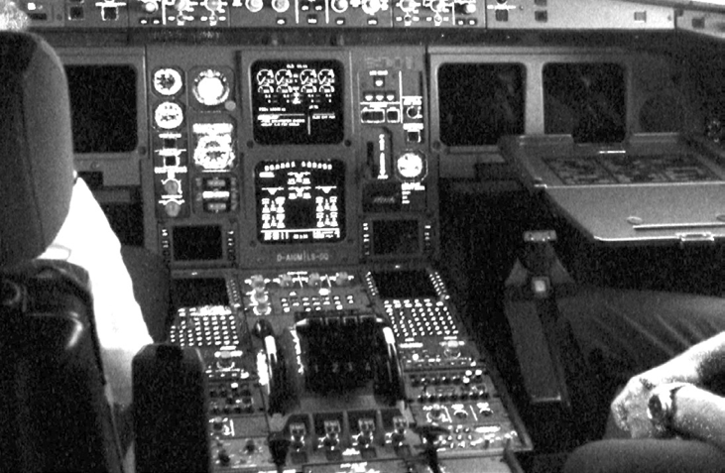

**Debugging a Crash**

***Objective: In this lab you will extend the knowledge gained in Lab 17a to diagnose what happened to the kernel that resulted in a crash.***

1. Examine the crash file labeled Lab17b.tar.gz to expand tar xvfz *<filename>*

**File(s) for this lab:**

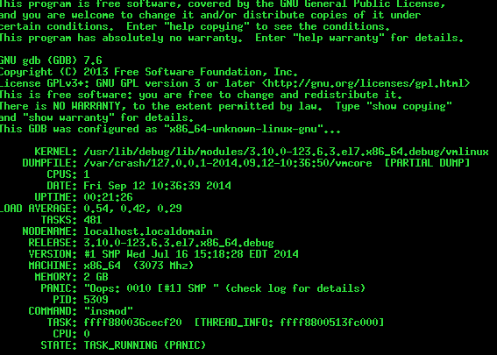

1. Use the features available in the crash command to identify the cause of the crash. List the commands you used to conduct your analysis and the information you gained.